Testing On Hostel Owner Done By Vaibhav Jadhav

1)While Doing Registering the UI is not User friendly ,make it good like increase the width of the form.

2)While Login It takes much time to Load the and navigate to the Dashboard see the Issue.

3) The Hostel Images are Not showing ,I think image is unable to fetch from backend ,see routes Issue.

4)Showing the Below Error when Owner goes to the Owner Dashboard:

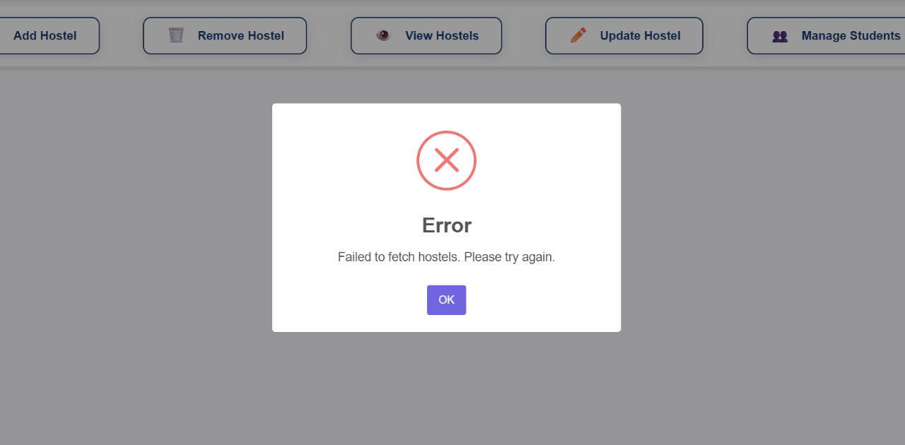

5) while Doing reset password the following error is occures:

